Learner Name: Sebastian Archer

BTEC First Diploma in Information and Creative Technology
Unit(s) A Technology Business | Unit code: 21  Unit credit:
Assessor: Karl Evans  Assessment IV: | Date issued:  Final deadline:

Approval of Assignment Brief
Name of IV approving brief:  Signature of IV: | Date assignment brief approved: 13/09/2021

Assignment Resubmission (if applicable) Yes / No
Name of Lead IV approving resubmission:  Signature of Lead IV: | Date assignment resubmission approved:



Unit 21 – A Technology Business
Assignment 1
Scenario

A website technology business wants to release a new technology-based product or service. The director of the company would like you to investigate suitable successful technology-based products and services.

Products – This is a physical item offered for sale. Every product is made at a cost and sold at a price. Examples of technology-based products include devices such as hearing aids, computers, games consoles, mobile phones, modems, digital cameras and printers, amongst many others.

Services – Services are transactions which do not involve physical goods. They are often open ended and involve a series of processes and systems, more often than use using the Internet. Examples of technology-based services include Youtube, Spotify, Internet Service Providers, Virtual Private Networks, Google Maps, email services, Office 365 and Moodle.

Learning Outcomes
Learning Outcome A - Understand the principles of marketing and investigate successful technology-based product(s) and service(s)

Assignment Tasks

Task 1 | - Write a report that explains six features and six functions of at least one successful technology-based product and one successful technology-based product service, giving examples of how they are used and what they are used for.  - Use at least one of the following technology-based products:  - A mobile phone  - A computer  - A games console/ computer game  - One of the following technology-based services:  - A web application/website  - A mobile application  - A desktop-based application
Task 2 | - Review the benefits of the product and the service.  - Discuss in detail one chosen successful product or service you have been investigating, consider its unique selling point and compare it with other at least two similar products or services offered by competitors.

Reading List:
See canvas

Assessment Evidence:
One written report.

Criteria:

To achieve a Pass grade the evidence must show that the learner is able to: | To achieve a Merit grade the evidence must show that, in addition to the Pass criteria, the learner is able to: | To achieve a Distinction grade the evidence must show that, in addition to the Merit criteria, the learner is able to:
P1 Explain the features and functions of at least one successful technology-based product and service. | M1 Review the benefits of at least one successful product and service. | D1 Discuss the unique selling point(s) of at least one successful product or service.

Learner Declaration:
I certify that the work submitted for this assignment is my own and research sources are fully acknowledged.

Learner signature: Date:

Learner Feedback on Completing Assignment

Assessment feedback is available on Moodle.

Assessment Results
Grading Criteria | Achieved? (Y/N)
P1 Explain the features and functions of at least one successful technology-based product and service
M1 Review the benefits of at least one successful product and service
D1 Discuss the unique selling point (s) of at least one successful product or service

Assessor Comments

Assessor Declaration:
I certify that the evidence provided is authentic and is the learner’s own work, and has been assessed in line with BTEC and Coleg Gwent assessment policies and procedures.

Assessor signature: Date:

Tesla

Features:
- It has a touchscreen.
The touchscreen has several uses, some of which include access to streaming services, in case you would like to enjoy a video while waiting for someone to get into your car. You can use the touchscreen to control the climate inside of the car, with options like temperature, direction, and speed of the airflow it’s producing. It can also be used to protect the vehicle with a PIN, which would be required to be inputted before being able to drive.

- Autopilot for Autonomous Driving
It’s a suite of an advanced driver-assistance system, which can physically drive the vehicle itself on a highway or open road. It may have trouble with smaller or rural areas.
It required active driver supervision to be able to operate, in case of a malfunction or issue with the road ahead.

- Supercharging is used to quickly charge the car battery.
Superchargers are ideal for long distance travel and are designed to charge your Tesla quickly so you can get back on the road. Charging Speeds to vary between vehicle models. To locate a supercharger, you can use the touchscreen map function.

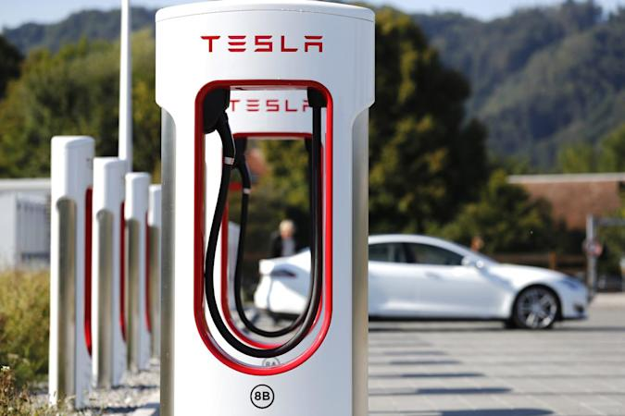

- Keycard access allows you to enter your car with only a card.
The Keycard is only intended for the Model 3.
It uses RFID to communicate with the car.

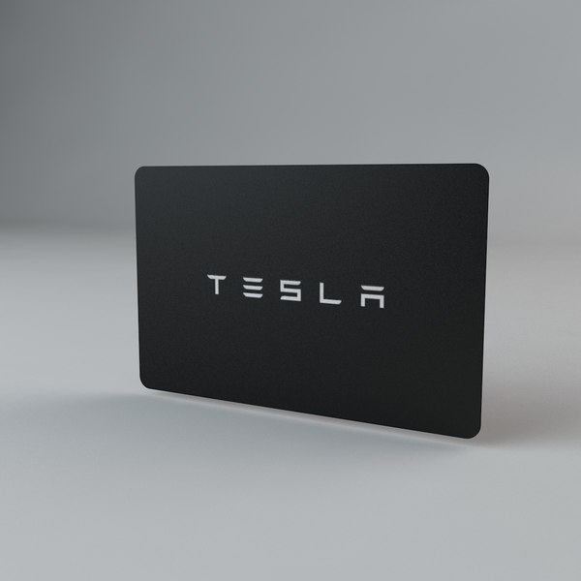
- Fart Mode, where you can make your Tesla make fart noises when different actions are made like indicating or steering.
(https://www.youtube.com/watch?v=seEVSFq3FmE)

- Connects to WiFi to play games, watch movies, and listen to music on the go via the touchscreen.

(Continue)

Functions:

      - You can drive it
      - Roll down Windows
      - Storage Area in the front and back
      - Onboard Diagnostics
      - Air Conditioning
      - Battery Powered

Camera

s

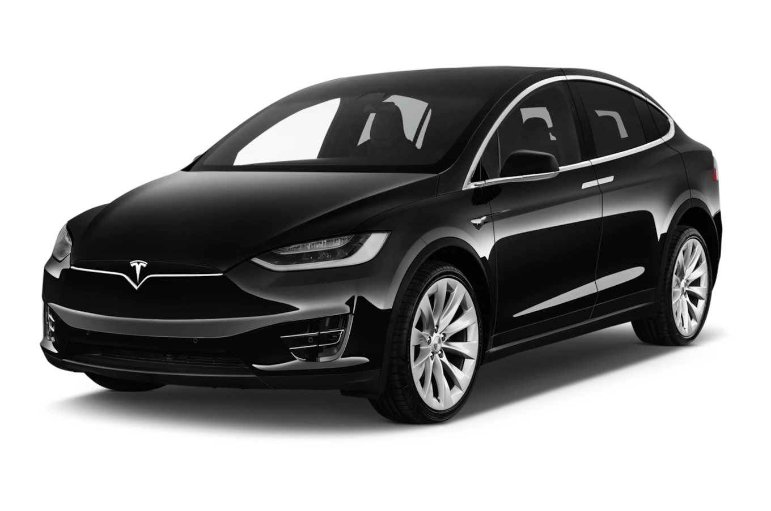

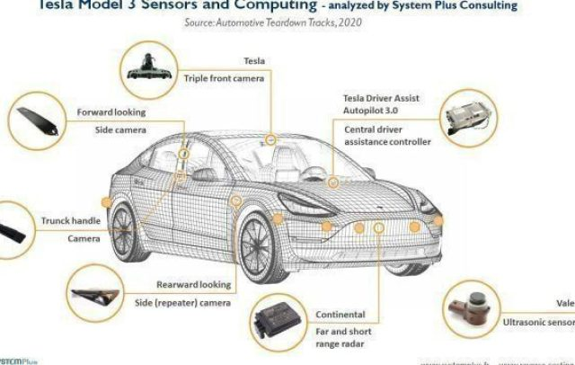

Task 2:

The features of the camera on the Tesla are useful because they can help direct the driver or provide insight to what caused damage done to the vehicle.

